Learn about TB as an infectious disease and the practical ways you can reduce your bTB risk or length of a TB breakdown.
TACKLING TB
in [County Here]
Sarah Tomlinson will also give an update on National TB policy and the overall disease picture across England.

[Date and Time Here]
[Location address here]

Discussion delivered by Sarah Tomlinson BVM&S MRCVS, TBAS Technical Director

To book your FREE place, please call or email using the contact information below:

COVID GUIDANCE

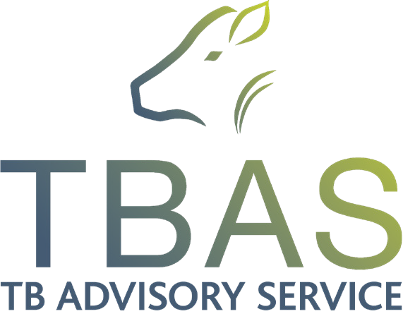
In light of the latest UK Government advice, we kindly request that all attendees wear face
coverings throughout the meeting unless exempt and do not attend if you are feeling unwell.

The TB Advisory Service offers FREE
bespoke advice to farmers in England.

E | info@tbas.org.uk | W | tbas.org.uk | T | 01306 779410
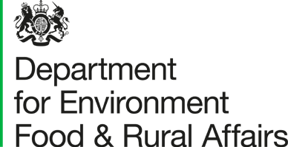
[Logos Here]

